**TRF Level 2 2022 Task Report**

Task No.:3

Title: Speed control of fan according to temperature sensor without using Microcontroller.

Name: Vaishnavi Ramchandra Davari

GR No.: 12110729

E-mail ID: vaishnavi.davari21@vit.edu

**INDEX**

|  |  |
| --- | --- |
| 1. | Introduction |
| 2. | Working methodology |
| 3. | Insights |
| 4. | Circuit Diagram (if any) |
| 5. | Result |
| 6. | References |

1. INTRODUCTION

This is template of task report. In this, describe your task.

Hardware:

(Components in the circuit)

Software : Proteus

(Software used)

2. WORKING METHODOLOGY

(Mention steps taken to complete the task)

**Working of the circuit/ Algorithm/ Flowchart/ Equation:**

(Explain the working of the circuit, algorithm, equations, calculations, simplication , etc)

* Temperature sensor basically measures the heat/cold generated by an object to which it is connected. It then provides a proportional resistance, current or voltage output which is then measured or processed as per our application.
* This simple temperature controlled DC fan circuit can be used to control any 5volt DC fan by activating it on a preset temperature. You can use this circuit in many electronic projects, which require a cooling fan. The circuit is very simple circuit to add in 30v dc power supply circuit
* The BD139 transistor is working as a switch here. When the 10K NTC thermistor will receive heat then its resistance will start decreasing and on a preset level the transistor BD139 will become switch ON and activates the 5 volt DC fan or motor.
* The 50K variable resistor is used to adjust the level of temperature or heat on which you want to switch ON the transistor.
* The transistor will dissipate heat during operation therefore it is important to add some distance between the thermistor and transistor or the circuit will not work properly. Also use a suitable heatsink with the transistor

3. INSIGHTS

(Problems (errors) faced while completing the task

Controlling the speed of motor at right time when temperature increases or decreases.

Finding appropriate sensor to perform the given task.

4. CIRCUIT DIAGRAM (if any)

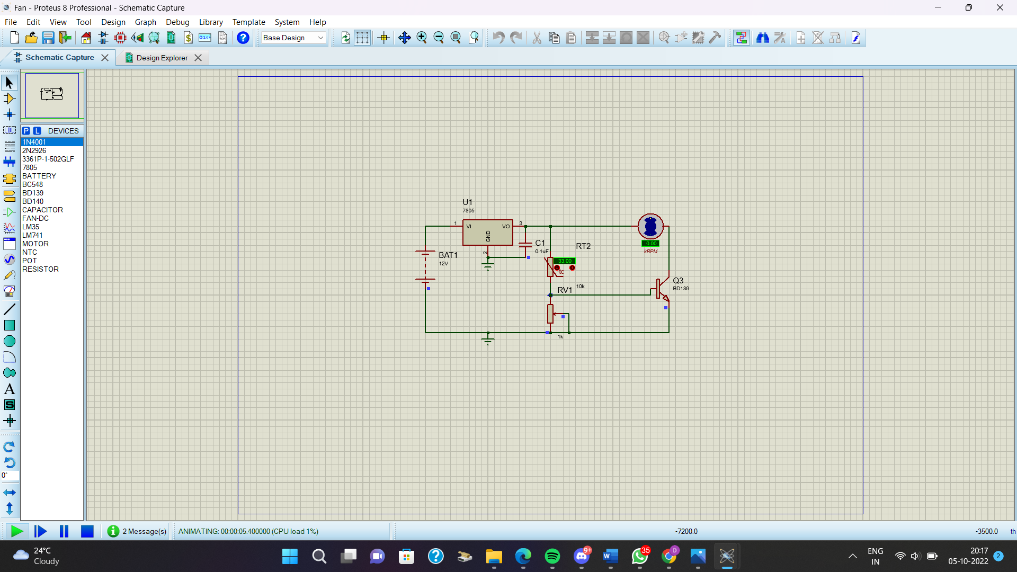5.

RESULT

(Attach Screenshot of Simulations, Output, Design, etc)

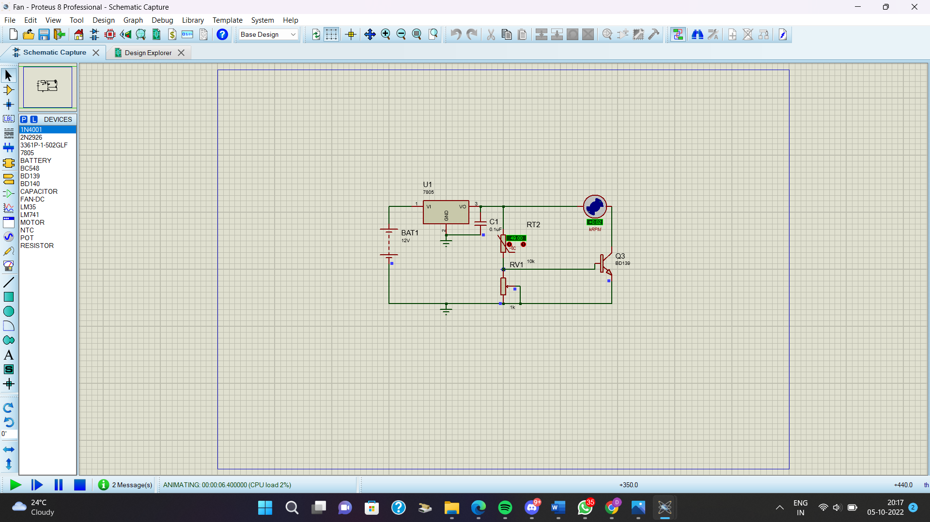

6. REFERENCES

(datasheets, sites that you used to complete the task)

<https://www.youtube.com/watch?v=I_eaUzNHvmU>

<https://www.youtube.com/watch?v=edx2m23g4Vo>

<https://www.vishay.com/docs/29053/ntcappnote.pdf>

<https://components101.com/resistors/ntc-thermistor-10k>